Link to Academic Writer from within a Course

This section provides instructions for system administrators, course designers, or instructors on how to create a link to the Academic Writer content landing page. Here the instructor can preview our collection of content, and select/copy individual links back into a course.

- Navigate to any Blackboard course and within that course to any content area.

- First we will create a link to the Academic Writer content landing page where we can preview and select specific APA content.

- Within the content area, from the Build Content menu, select Web Link.

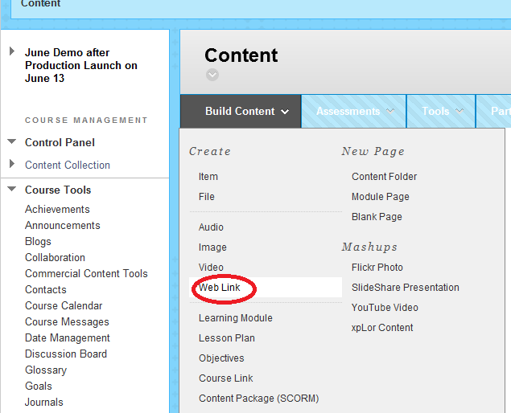

- On the Create Web Link form:
  - Provide the Name of the link such as “Select APA Content”. Provide a label that clearly identifies the action.
  - Provide the production URL to the APA LTI Tool https://my.apa.org/ltigateway/lti?ERIGHTS_TARGET=http://apastylecentral.apa.org/learnbb
  - Check the box to confirm this link is to a Tool Provider.
  - Select this web link to open in a new window.
  - Select NO to permit users to view this content. This link is for instructors to select content, not for students to click.

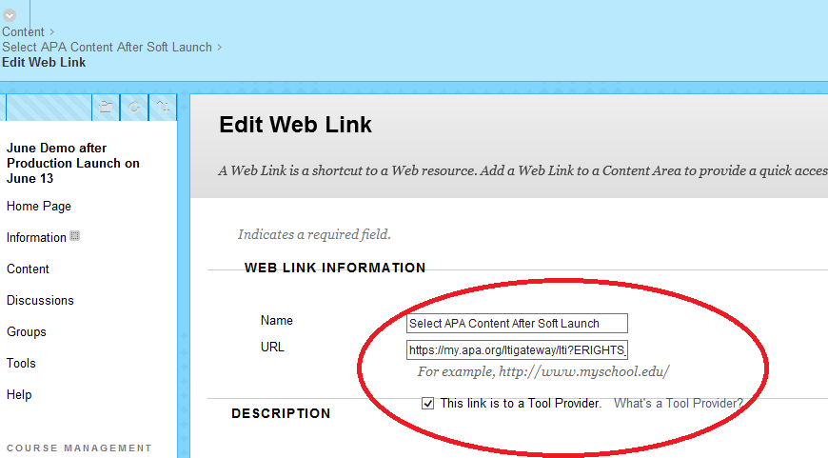
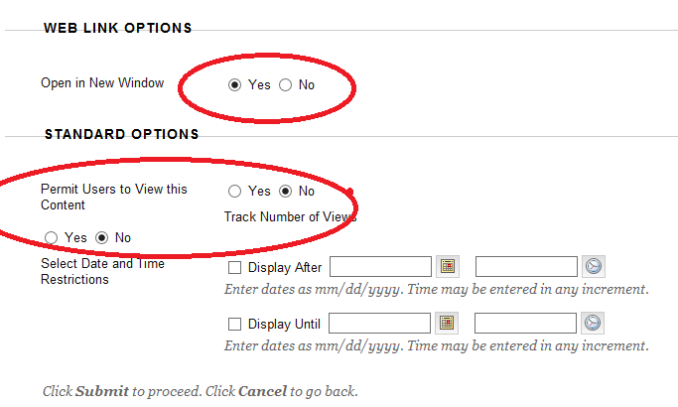

  - Submit the form to create the link to the Academic Writer content landing page.
Note: The text “Availability: Item is not available” means that the link is not available to anyone other than the system administrator, course designer, or instructor.

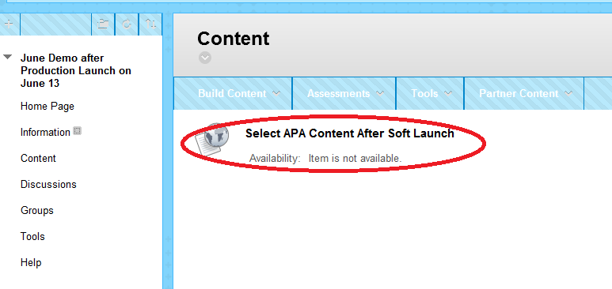

  - Click on the link (Select APA Content) to launch the Academic Writer Content Selection Page in a new window. You may be asked to log in or create a free account before you can access the page.

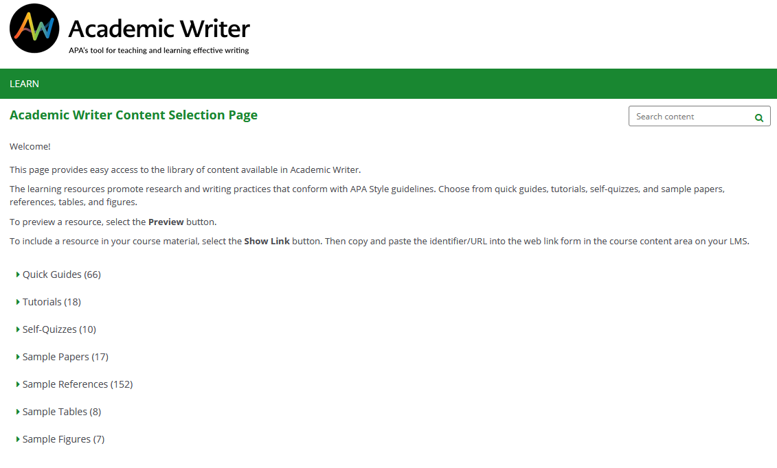

- From the landing page, discover and preview any content. When you have decided on a specific item, follow the instructions on the page to display and copy the URL for that item.

- Back in Blackboard – navigate to your content area. You are now going to create an individual link to a specific piece of content the same way that you created the web link to the Academic Writer Content Selection Page.
  - Within the content area, from the Build Content menu – select WEB LINK.
  - Provide the Name of the link such as “View APA Style Tutorial”. The name should clearly identify the action to be taken on the content.
  - Copy the content URL from the clipboard (e.g., https://my.apa.org/ltigateway/lti?ERIGHTS_TARGET=http://apastylecentral.apa.org/learndisplay/TUT-11). This URL is unique to a specific piece of content. In this example – it is the APA Style Tutorial.
  - Check the box to confirm this link is to a Tool Provider.
  - Add any desired description.
  - Select this web link to open in a new window. (Important: If this is set to “No”, content will not display.)
  - Select YES to permit users to view this content as you want your students to be able to view this content as part of their course assignments.
  - Click Submit.
  - Repeat this process as needed. You can select from multiple quick guides, tutorials, self quizzes, sample papers, sample tables, references, etc.

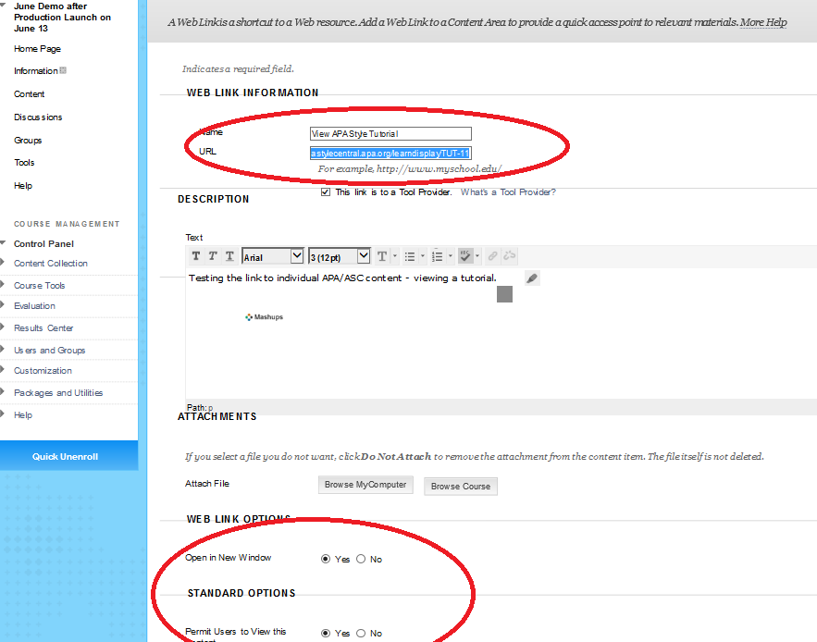

- This completes the LTI configuration and content access process. To verify links, click on them using an instructor or student account. The appropriate Academic Writer content should appear/play in a new window.

