Import Pre-Formatted Test Sets and a Test Pool/Bank

In addition to the various learning objects available via the Academic Writer landing page, APA is also providing ten pre-formatted tests along with a pool of questions that instructors can use to create their own tests. The pre-formatted tests are packaged as SCORM 1.2 content and should load easily on your LMS. They were developed as highly interactive tests with 10-13 questions and a summary score and e-mail feature at the end of each test.

The test pool is packaged in the IMS Question and Test Interoperability (QTI ) format using Common Cartridge v1.1. The file name carries the .imscc extension which informs the LMS of the file format.
Note: LMS System administrators, instructors, and course designers are well versed in these terminologies and uses.

To obtain preformatted tests and/or the pool of individual questions, contact Andrew Welch (andrew.welch@drake.edu) at Cowles Library. The following preformatted tests are available:

- APA Style Basics
To prepare for this test, students should review the following tutorial: Getting Started With APA Style
- Citing Sources
To prepare for this test, students should review the following quick guides: Direct Quotations and Paraphrasing, Secondary Sources, Personal Communications, Copyright and Permissions, and Citing References in Text
- Ethics, Plagiarism, and Copyright
To prepare for this test, students should review the following tutorials: Ethical Standards in Writing and Research, How to Avoid Plagiarism and Self-Plagiarism, and The Basics of Copyright and Permission
- Formatting and Organizing
To prepare for this test, students should review the following quick guides: Basic Setup, Title Page, Running Head, Heading Levels, Lists, Footnotes, Alphabetizing the Reference List, Order of Sections, Abstract and Keywords, Introduction, Method, Results, Discussion, Reference List, and Appendices
- How to Report Scientific Research
To prepare for this test, students should review the following tutorial: How to Report Scientific Research
- Introduction to Research
To prepare for this test, students should review the following tutorials: The Rules of Evidence in Science, Research Questions and Hypotheses, Research Strategies and Variables, The Sample, Confounding Variables and Their Control, Research Designs and Threats to Internal Validity, Criteria and Criterion Measures, and Analyzing Data and Drawing Conclusions
- Mechanics of Style
To prepare for this test, students should review the following quick guides: Periods, Commas and Semicolons, Colons, Hyphens, Quotation Marks, Parentheses and Brackets, Slashes, Capitalization, Italics, Abbreviations, Numerals Versus Words, and Presenting Statistics in Text
- Reference List
To prepare for this test, students should review the following quick guides: Reference Elements, Missing Reference Elements, Electronic Sources and Locator Information, Journal Article Reference, Magazine Article Reference, Newspaper Article Reference, Book Reference, Book Chapter Reference, Reference Work and Reference Work Entry, Technical or Research Report Reference, Meeting or Symposium Reference, Dissertation or Thesis Reference, Audiovisual Material Reference, App or Software Reference, Unpublished or Informally Published Work Reference, Website Reference, Social Media Reference, and Blog Post Reference
- Tables and Figures
To prepare for this test, students should review the following quick guides: Table Guidelines, Table Components, Figure Guidelines, and Figure Components
- Writing Style
To prepare for this test, students should review the following quick guides and tutorial: Smooth Expression, Tone, Concise Expression, Precision and Clarity, Continuity in Writing, Types of Research Papers, Gender, Sexual Orientation, Racial and Ethnic Identity, Disability, Age, Historical and Interpretive Accuracy, How to Reduce Bias in Language: Writing About Individuals With Respect and Objectivity

Import the Pre-formatted Test Sets into a Blackboard Course

- In Blackboard, navigate to your content area.

- Go to Build Content.

- Select “Content Package (SCORM)”.

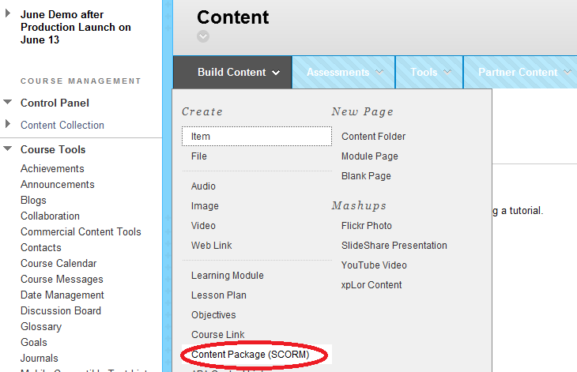
- Browse your local directory to find your ten preformatted tests. As with most SCORM packages, the file extension is .zip.

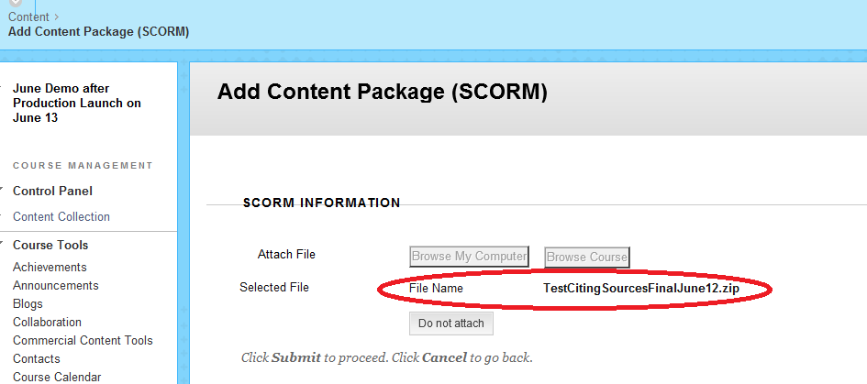

- Click Submit.

- Complete title and description.

- If you are ready to reveal the test to students in the course content, select YES to make SCORM available. If not, select NO and remember to edit that field once you are ready to post the pre-formatted test as course content.

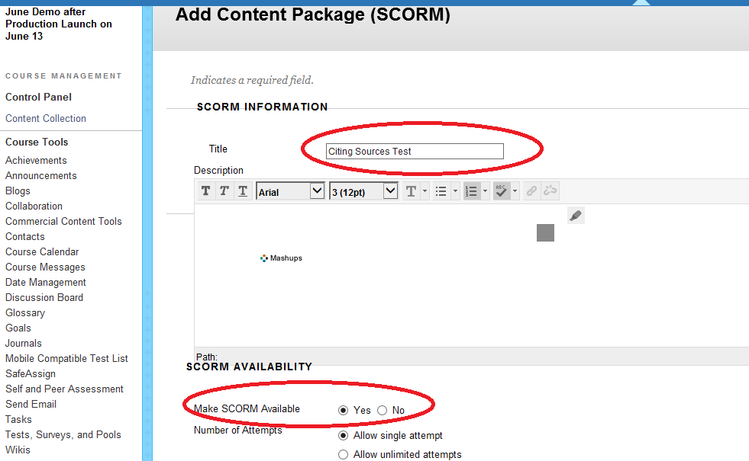

- In the Advanced Options area, next to Edit SCORM Player Behavior, select YES. Under Navigational Controls, click Rudimentary Rollup.

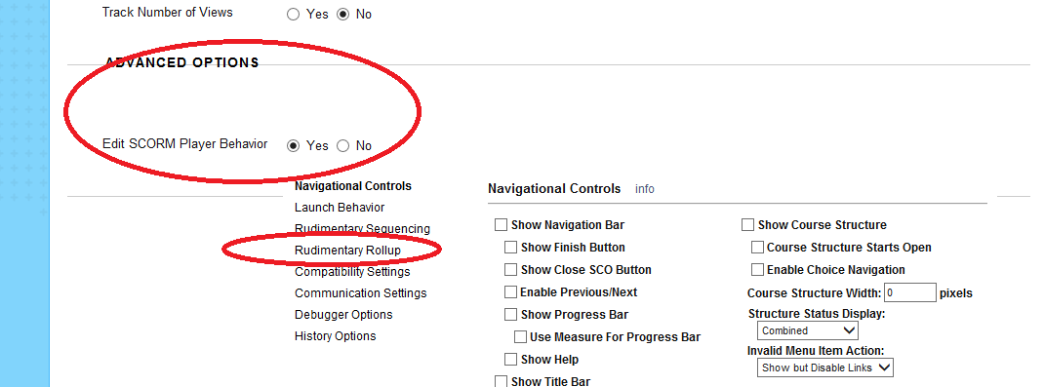

- In the Rudimentary Rollup menu, set Status Rollup Mode to “Complete When Threshold Score is Met.”

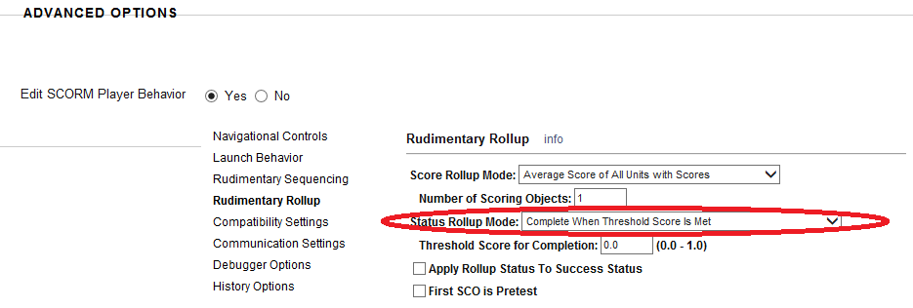

- In the Evaluation section, select “When SCORM is completed, display score in Grade Center.”

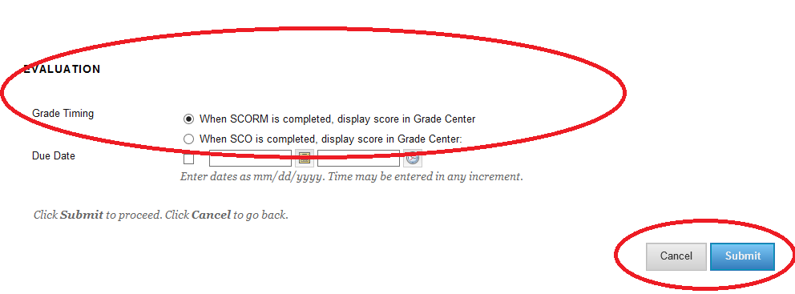

- Click Submit. The test should appear in your content area ready to be taken by students as assigned.
Reminder: Your ten pre-formatted tests have been packaged as SCORM content and will be visible to students as another piece of content – and not part of “tests, surveys and pools” as labeled in your Blackboard LMS.

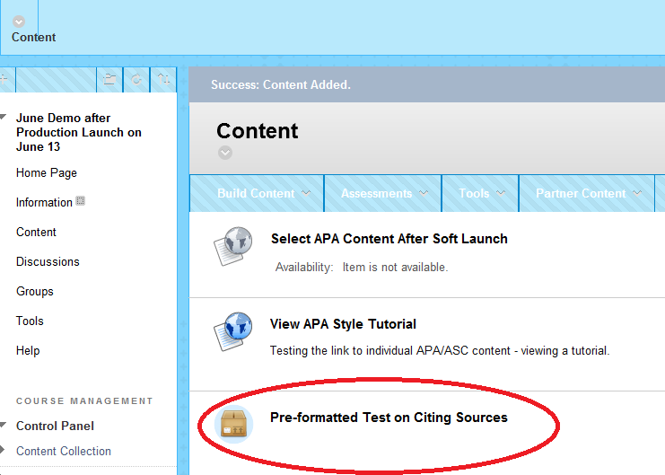

- In this example, click on Preformatted Test on Citing Sources to launch the test. The final page of each test will display the score, and includes an option for the user to send an email reporting their results.

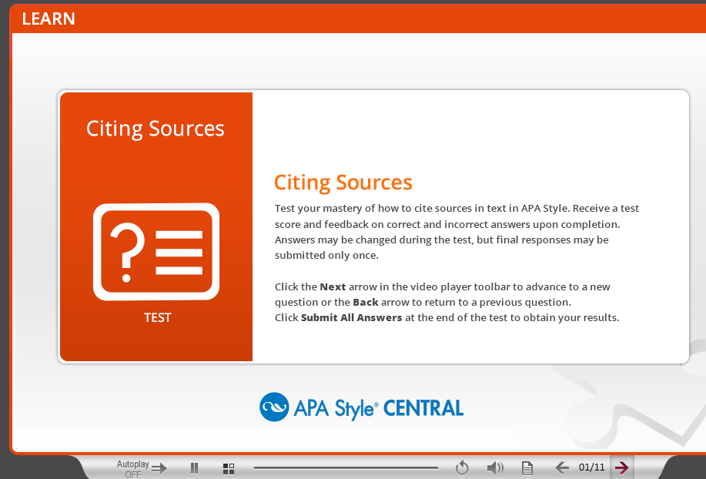

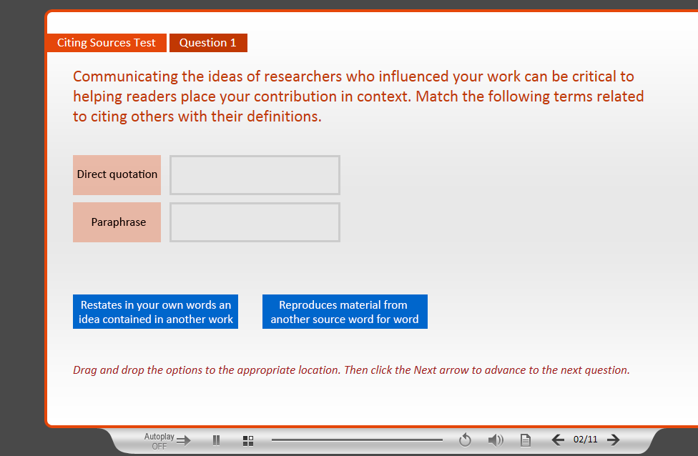
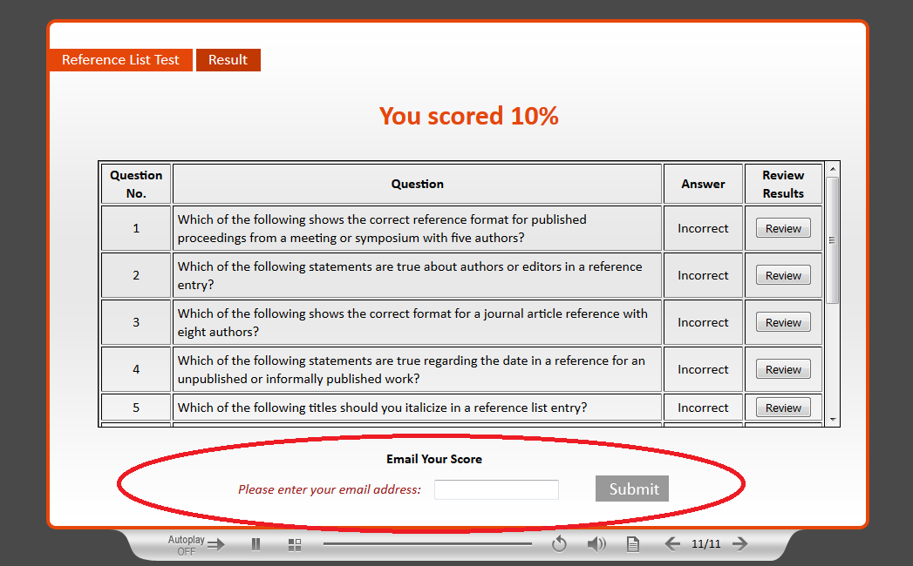

Import the Test Pool QTI Package into a Blackboard Course

- Go to Packages and Utilities from the Course Home Page.

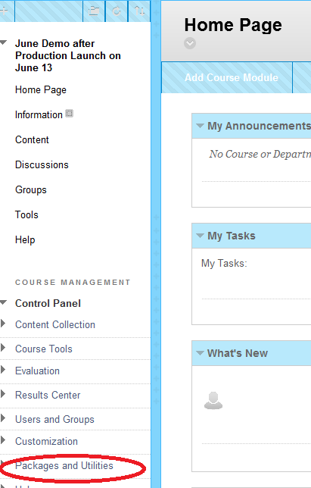

- Go to Import Package/View Logs.

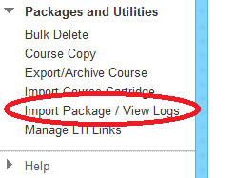

- Select a Package. Browse and find your .imscc file.

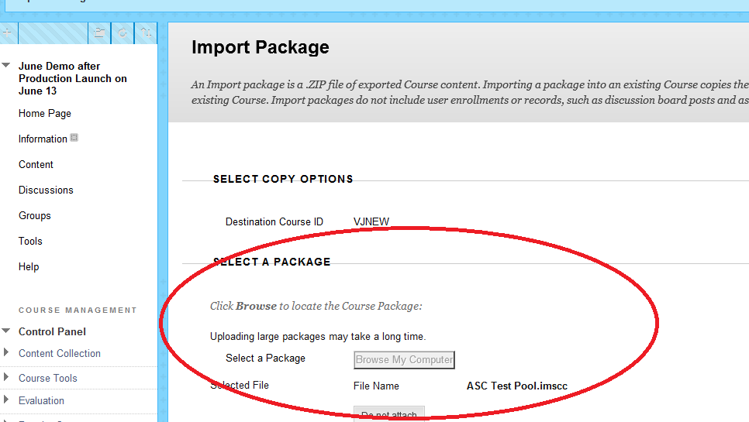

- Select Course Materials. Click on Tests, Surveys and Pools.

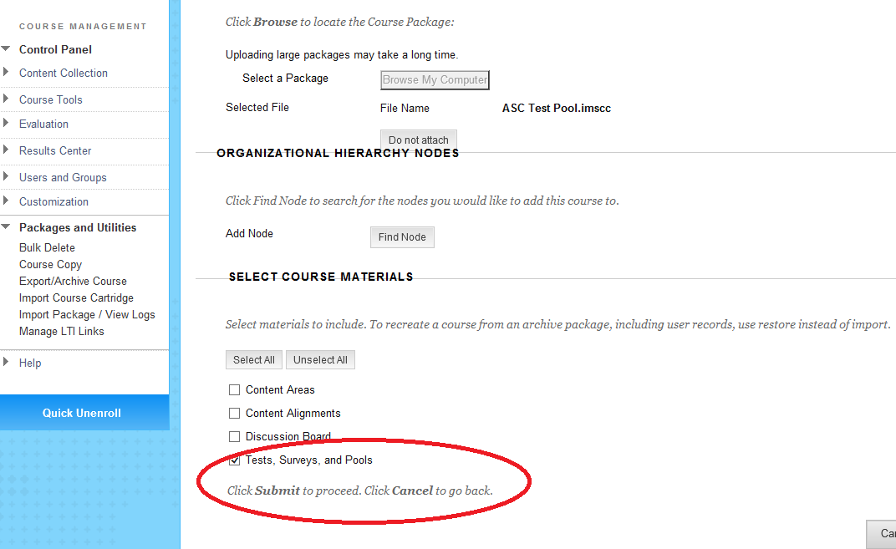

- Click Submit.

- The action will be queued and you will be notified via email that the import was successful.

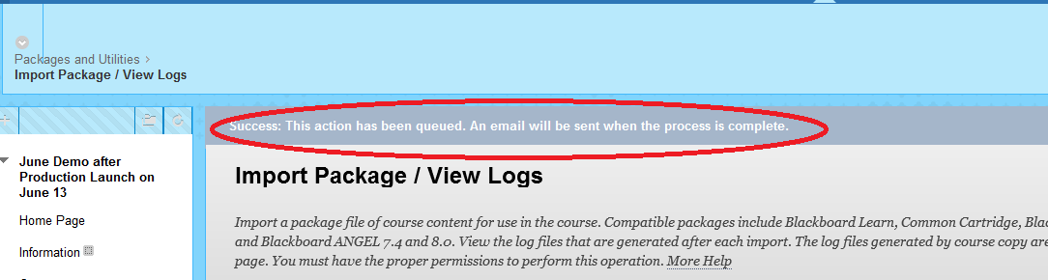

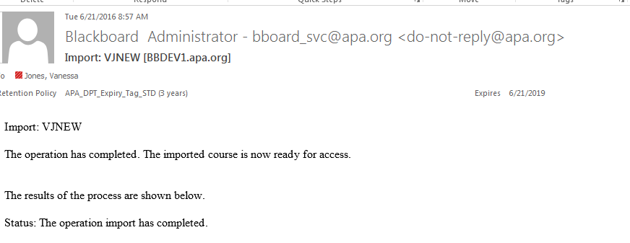

- The test pool (import file) is now available for use. Instructors can build their own test and reuse questions from the test pool.

