Import Pre-Formatted Test Sets and a Test Pool/Bank

In addition to the various learning objects available via the APA Style CENTRAL landing page, APA is also providing ten pre-formatted tests along with a pool of questions that instructors can use to create their own tests. The pre-formatted tests are packaged as SCORM 1.2 content and should load easily on your LMS. They were developed as highly interactive tests with 10-13 questions and a summary score and e-mail feature at the end of each test.

The test pool is packaged in the IMS Question and Test Interoperability (QTI ) format using Common Cartridge v1.1. The file name carries the .imscc extension which informs the LMS of the file format.
Note: LMS System administrators, instructors, and course designers are well versed in these terminologies and uses.

To secure this content, we have loaded the files onto a secure content site where authorized users can retrieve them: http://www.apastyle.org/asc/secure/default.aspx. We encourage you to download your files to a secure local drive until you are ready to upload them to your LMS. Access to the test file requires a free APA account. If you do not already have one, create one at https://my.apa.org/apa/idm/register.jsf?ERIGHTS_TARGET=/apa/portal/home.seam

Import the Pre-formatted Test Sets into a Blackboard Course

- In Blackboard, navigate to your content area.

- Go to Build Content.

- Select “Content Package (SCORM)”.

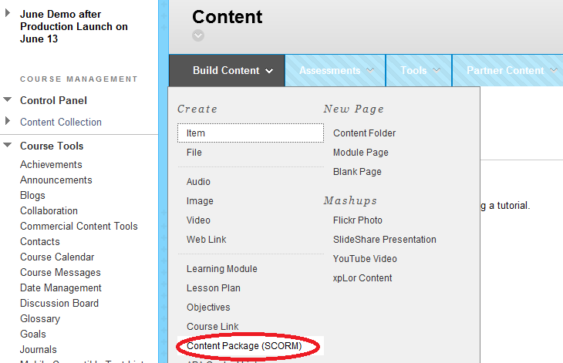
- Browse your local directory to find your ten preformatted tests. As with most SCORM packages, the file extension is .zip.

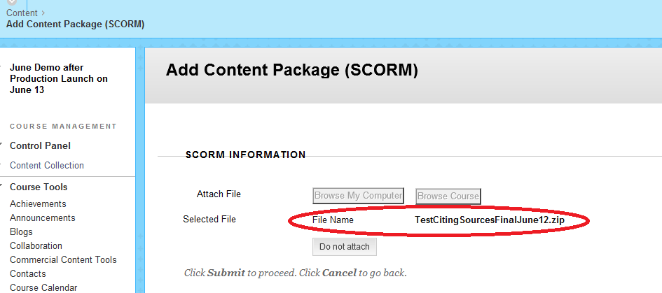

- Click Submit.

- Complete title and description.

- If you are ready to reveal the test to students in the course content, select YES to make SCORM available. If not, select NO and remember to edit that field once you are ready to post the pre-formatted test as course content.

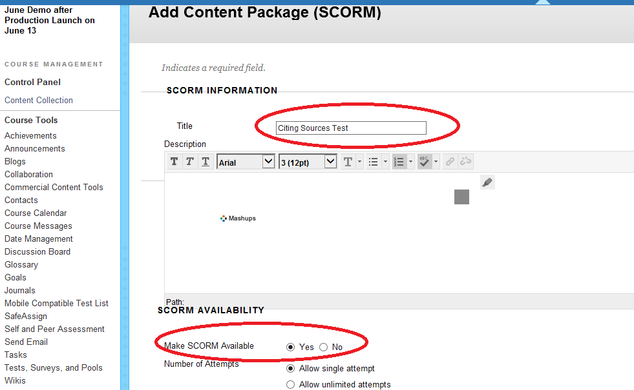

- In the Advanced Options area, next to Edit SCORM Player Behavior, select YES. Under Navigational Controls, click Rudimentary Rollup.

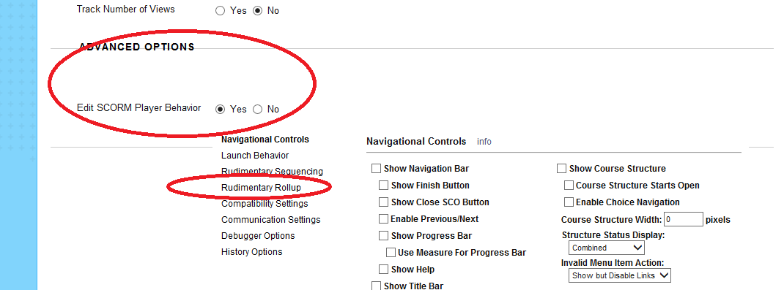

- In the Rudimentary Rollup menu, set Status Rollup Mode to “Complete When Threshold Score is Met.”

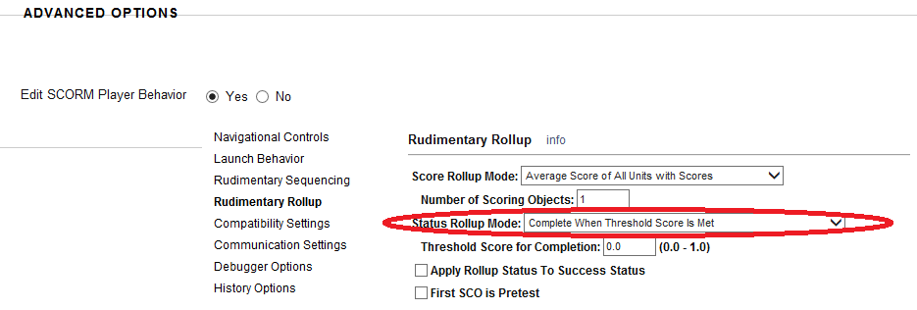

- In the Evaluation section, select “When SCORM is completed, display score in Grade Center.”

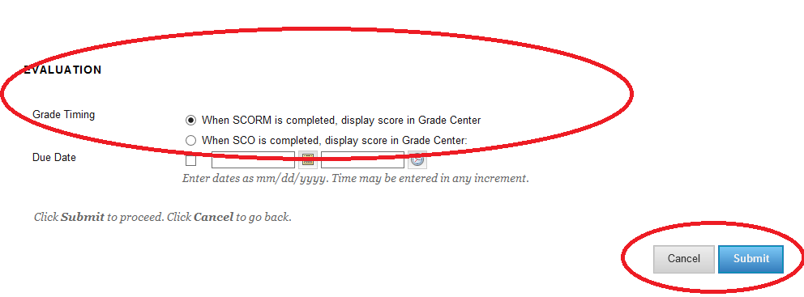

- Click Submit. The test should appear in your content area ready to be taken by students as assigned.
Reminder: Your ten pre-formatted tests have been packaged as SCORM content and will be visible to students as another piece of content – and not part of “tests, surveys and pools” as labeled in your Blackboard LMS.

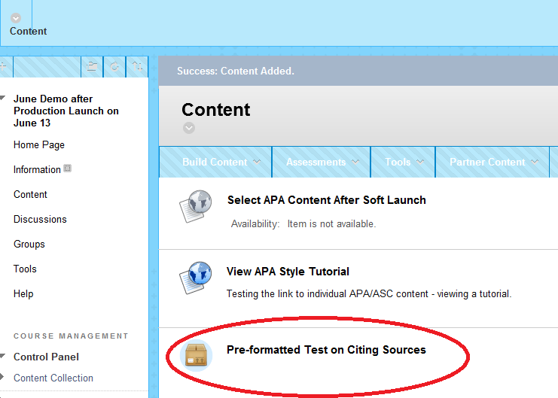

- In this example, click on Preformatted Test on Citing Sources to launch the test. The final page of each test will display the score, and includes an option for the user to send an email reporting their results.

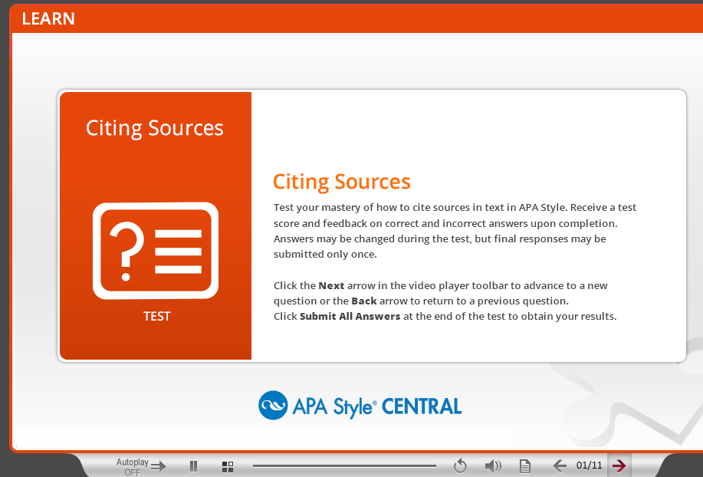

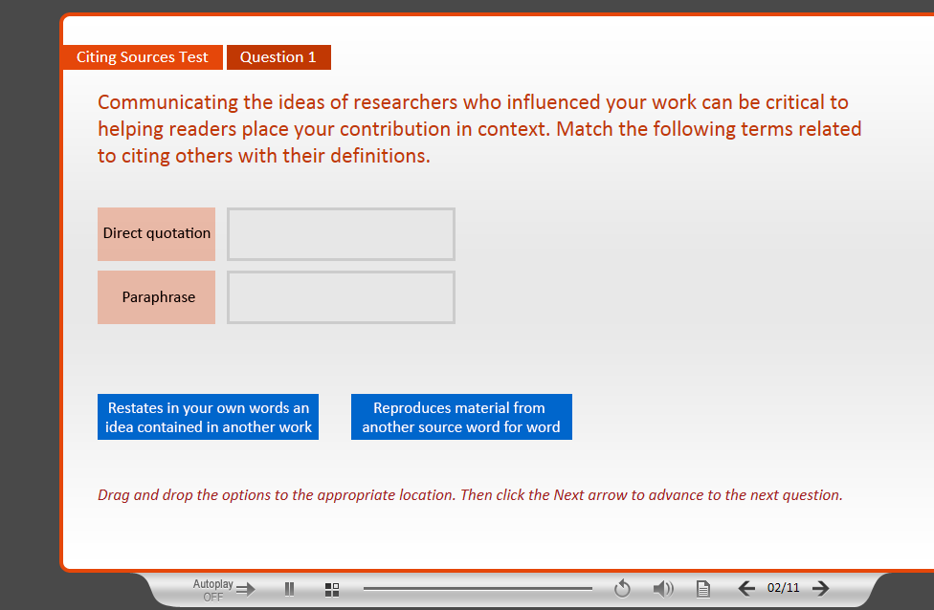
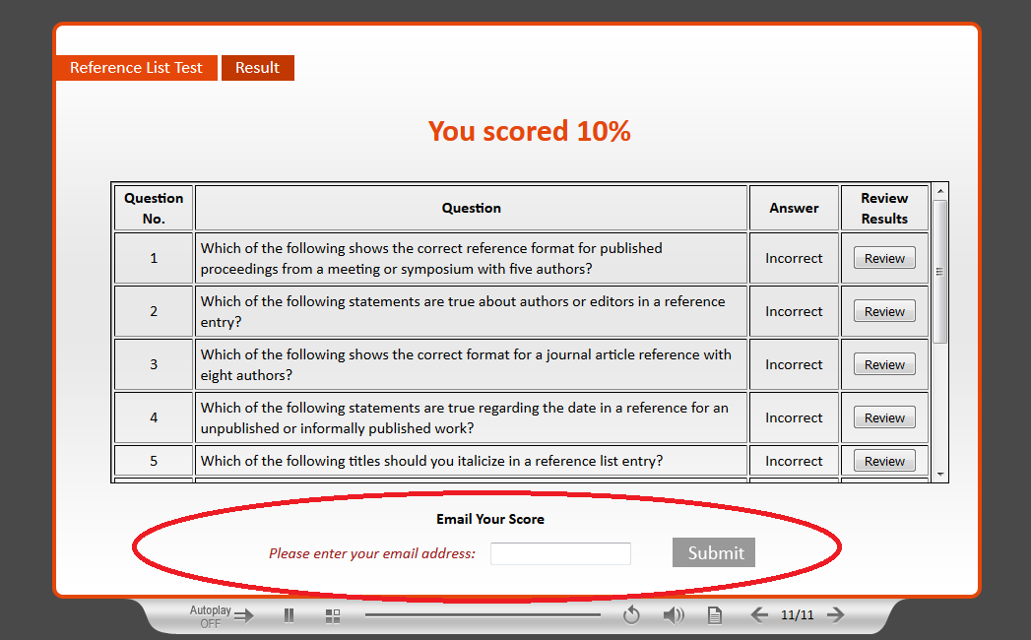

Import the Test Pool QTI Package into a Blackboard Course

- Go to Packages and Utilities from the Course Home Page.

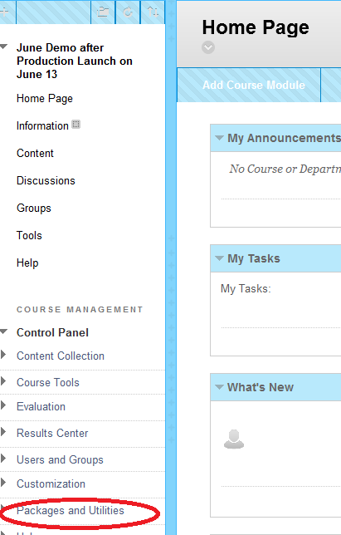

- Go to Import Package/View Logs.

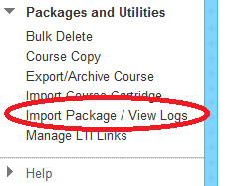

- Select a Package. Browse and find your .imscc file.

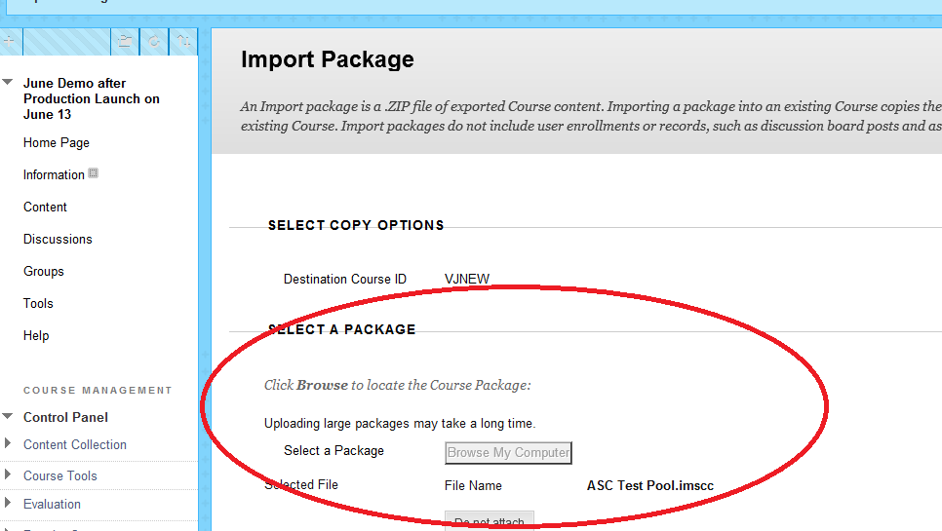

- Select Course Materials. Click on Tests, Surveys and Pools.

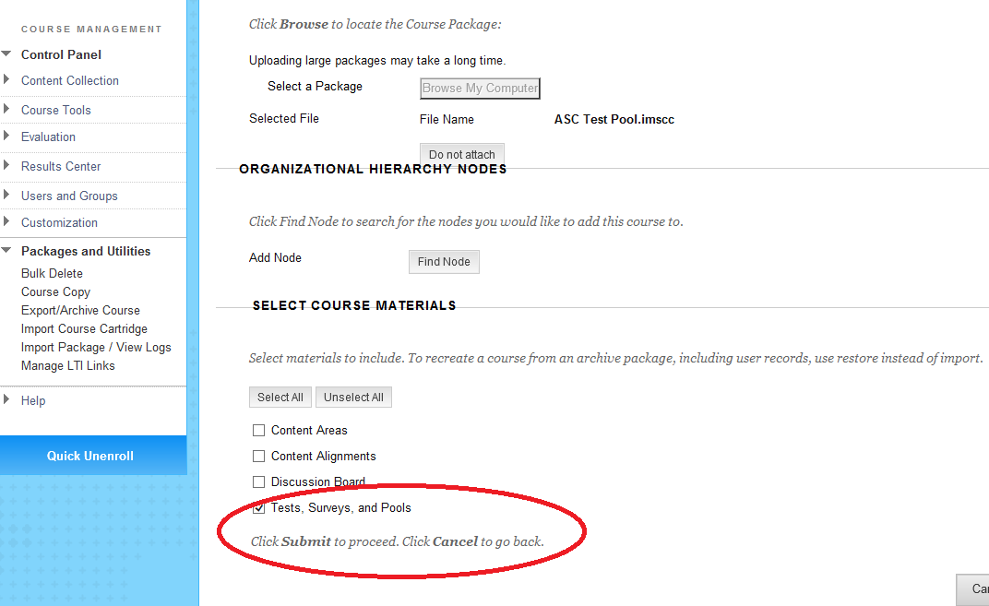

- Click Submit.

- The action will be queued and you will be notified via email that the import was successful.

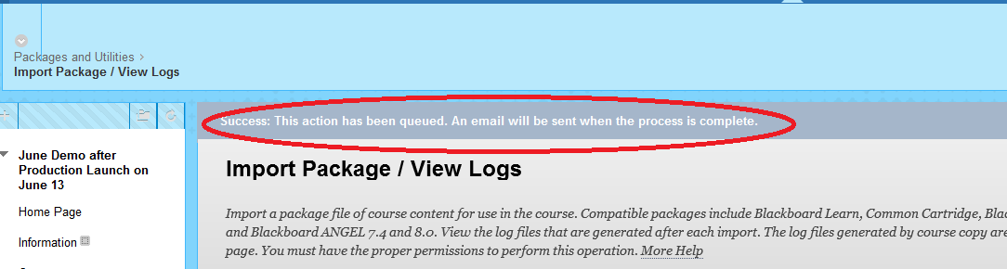

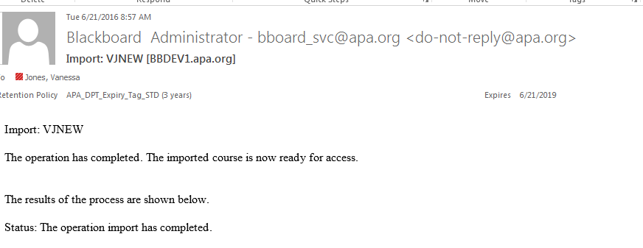

- The test pool (import file) is now available for use. Instructors can build their own test and reuse questions from the test pool.

